87472743622
830130400046
УМАРОВА Сулушаш Сюндиковна,
Сырбек Каттебеков атындағы жалпы білім беретін мектебінің
ағылшын тілі пәні мұғалімі.
Түркістан облысы, Шардара ауданы

TALKING ABOUT ABILITY

Learning objectives | 3.1.4.1 understand basic personal questions;  3.2.3.1 respond to basic questions with single words or short responses;  3.3.3.2 find out the main points in short simple descriptions with visual support;  3.5.1.13 use can/ can’t to describe ability.
Lesson objectives  (assessment criteria) | Learners will be able to:  to learn how to talk about ability;  to make short dialogues on the topic;  to use can/ can’t to describe ability.
Values ​​and its purpose: | "Law and Order"  Observance of norms and rules of order and justiceunderstand the need

Stages/  Time | Teachers actions | Students actions | Assessment | Resources
Beginning of the lesson  10 min | Organization moment :  1.Greeting. . (Whale class, Individually)  Ask hometask.  New words.  A teacher shows Sts. a flashcard and asks a question: Can you run?  A teacher can use a mime to help children to understand.  Active words: run, fly, walk, talk, ride a bike, ride a scooter.  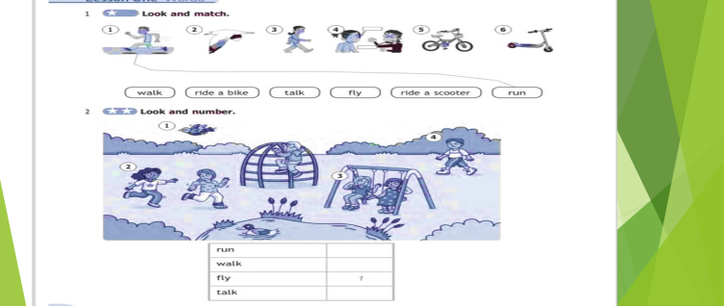  Ex:3. Look, listen and read the story.  Ask comprehension questions, e.g. Can Action Boy run/ fly/walk/talk?  Ask children to open their Pupil's Books and follow the story as you play the recording again.  Ask children to find and point to the words from Exercise 1 that appear in the story  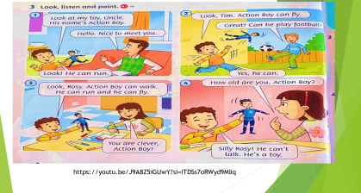  New lesson.  Talk about ability.  Can and can’t are modal verbs used in English to express ability, possibility, permission or requests.  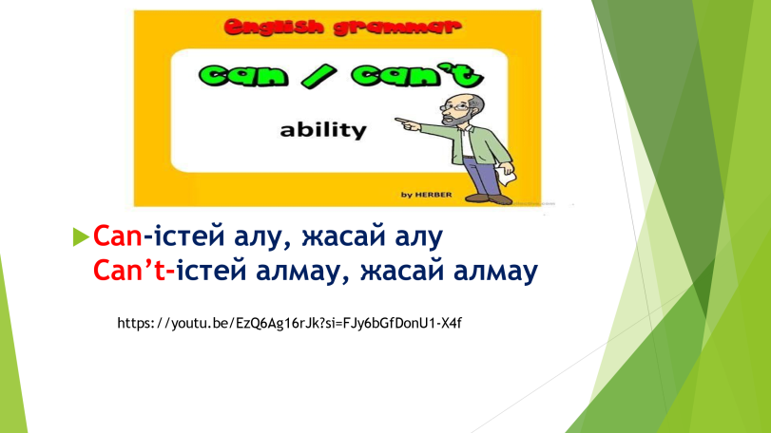 | Learners identify characters and potentially share details from the previous lesson.  Sts. name a verb and make up sentences with a modal verb can.  Sts. answer: Yes/ No and give a full sentence.  Learners look at the story and check how many of the actions they remembered in the lead-in activity | Teacher controles the process, gives feedback and asks additional questions if it’s nessasery.  Teacher evaluate pupils with phrases like:  “Good job!  Well done!”  Formative Assessment  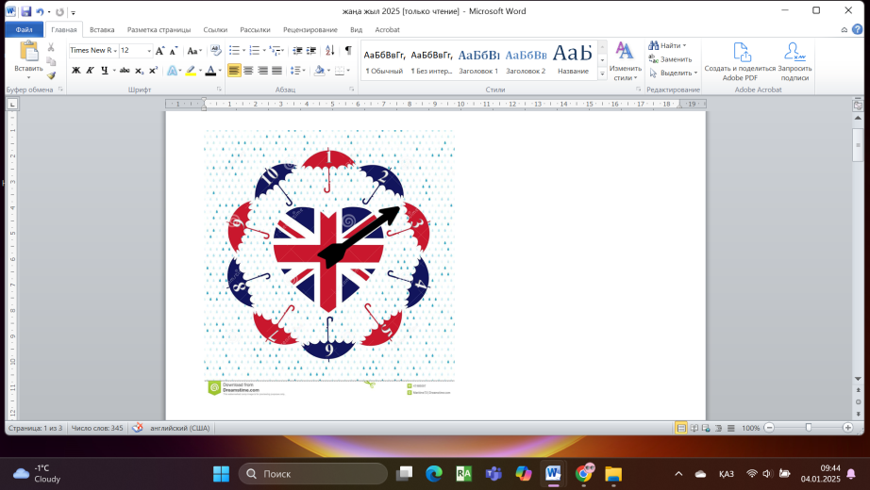 |   Flashcards  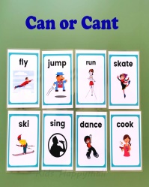  https://youtu.be/J9A8Z5iGUwY?si=iTDSs7oRWyd9Mliq  https://youtu.be/EzQ6Ag16rJk?si=FJy6bGfDonU1-X4f
Middle of the lesson  Presentation part.  30 min | Task. I  - Look and circle.  - Look and match.  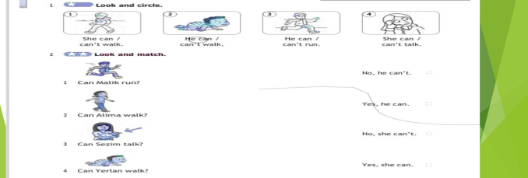 | Sts.circlethe correct words and match with sentences. | Descriptor:  - circle the correct words  - match with sentences.  
 | Task II  Look at picture in the Let's learn! box and ask children what they can see. Copy the sentences from the box onto the board, leaving spaces where the action words are.  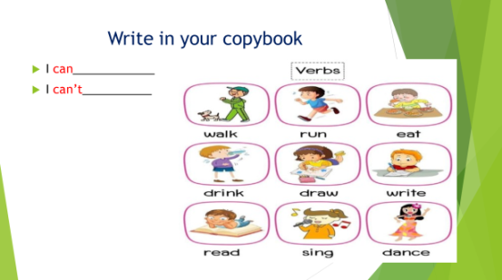  . | Pupils look at each picture in the Let's learn! Copy the sentences and questions from the box onto the board.  ANSWERS | T’s feedback  Descriptor:  - look at each picture  - copy the sentences  Total: 1 point | pictures
 | Refreshment moment.  Task. III Group work.  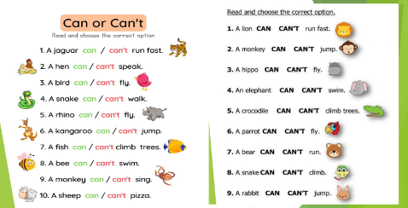 | Learners read each word and circle the correct modal verbs. | Descriptor:  - read each word aloud  - repeat chorally.  Point 2 | https://youtu.be/WX8HmogNyCY  pictures
 | Task. IV  Ex: 4 P: 33  Look at the table and answer the questions.  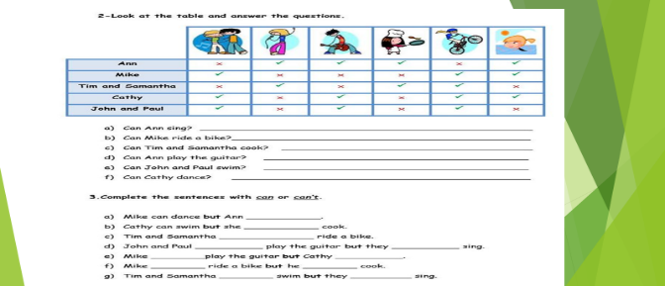 | Learners read the sentences and answer the questions  ANSWERS  1 Ann can sing. | Descriptor:  - read the sentences  And answer questions  Point 2 | picture
End of the lesson  5 min | 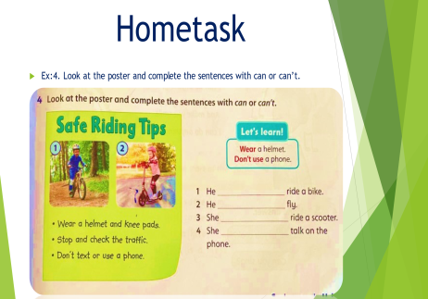 | Pupils evaluate themselves using evaluation lists.  Reflection.  Self- Assessment.  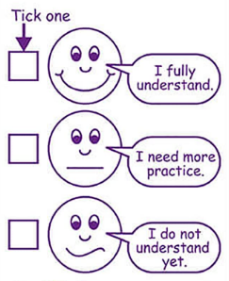 |  | Poster Success  

